**Exercise #5**

Let us consider two channels that are modeled as linear filter and AWGN. The impulse responses of the two channels are drawn below:

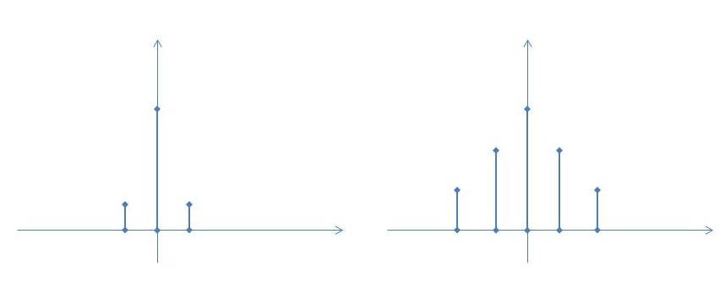

1. (b)
2. In which case is more important to use an equalizer at the receiver?
3. When the equalizer is not used, how do you expect that the BER curve look like?

**Exercise #5**

The following are the channel frequency responses of 3 different channels affected by ISI.

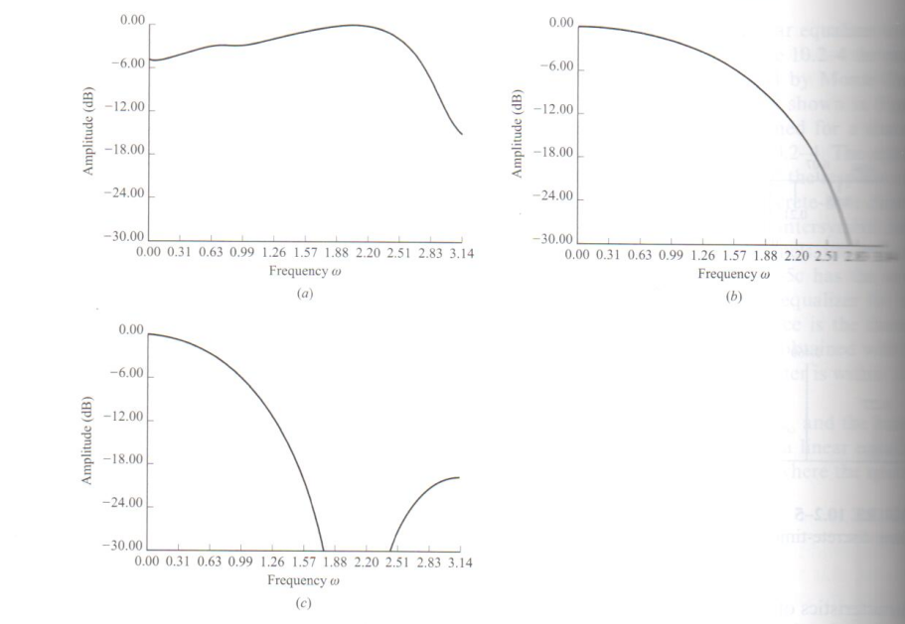



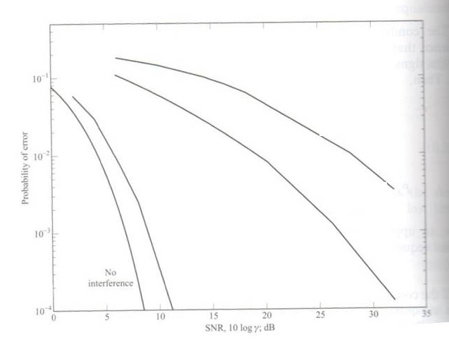

In the following figure there are the relative BER curves after MMSE equalization.

1. Associate each BER curve with the proper channel frequency responses
2. When the equalizer is not used, how do you expect that the BER curves look like?

**Exercise #4**

A bandpass communication system uses the constellation shown in the following Figure. The noise is AWGN with power spectral density N0/2.

1. Calculate the energy per bit as a function of a
2. Calculate the BER (assume Gray coding and not too low SNR)
3. Compare the BER with the BER of a QPSK with the same energy per bit

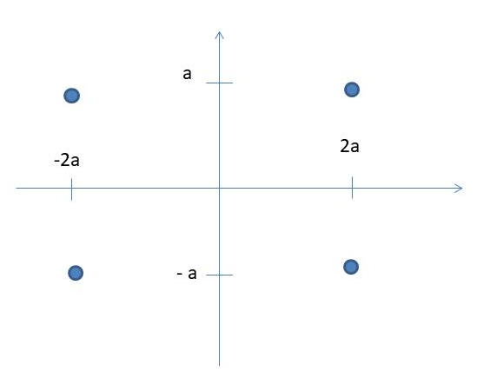

**Exercise #3**

In an additive white Gaussian noise channel with noise power spectral density of N0/2, two bits are transmitted by



The two messages are transmitted with a priori probabilities p and (1-p), respectively.

1. Determine the average energy transmitted per bit 
2. Determine the optimum threshold
3. Determine the structure of the optimal receiver (including the detector after the sampler)
4. Determine the probability of error in case p=(1-p)=0.5.

**Exercise #4**

If the maximum BER is 10(-4) and SNR is 15dB, which constellations guarantees the maximum bit rate? What is the maximum theoretical bit rate in case with no ISI if the bandwidth available is 3kHz?

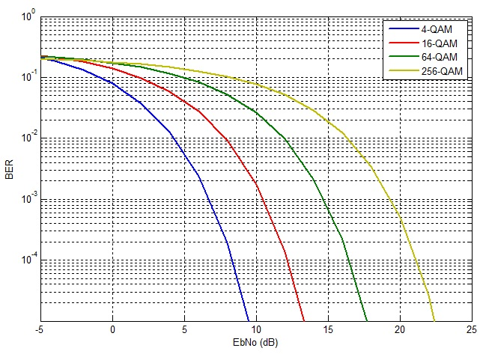

**Exercise #2**

A binary communication system uses the following pulse:

**

where *ψ*(*t*) is a unit-energy rectangular pulse of duration is 3 seconds.

1. it is an antipodal or orthogonal modulation?
2. Determine the energy per bit, *Eb*.
3. Sketch carefully a block diagram of the demodulator. In particular, you must give a detailed specification of the impulse response of the matched filter, the sampling time, and the decision rule
4. Noise at the receiver is AWGN with **. Determine the probability of a bit error, *Pe*
5. By mistake, the transmitter sends the pulse shown in figure below. Determine the resulting probability of a bit error, *Pe,*mistake.

